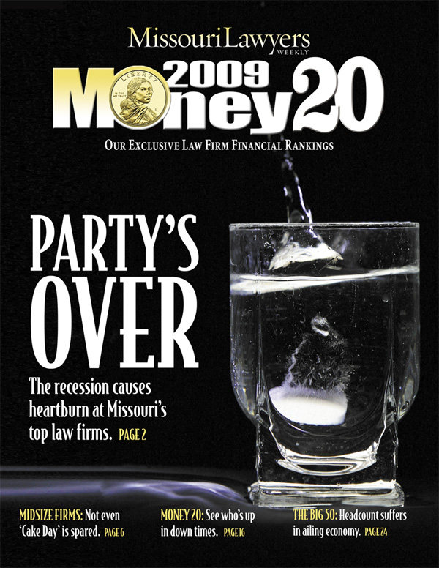
Contact: S. Richard Gard, Publisher FOR IMMEDIATE RELEASE
Telephone: 314-558-3210
Email: richard.gard@molawyersmedia.com
A Sobering Year
Missouri Lawyers Weekly
MOney 20 Magazine

St. Louis, MO – The business of law in Missouri is serious business. In 2008, combined annual gross revenues for Missouri’s 20 top grossing firms accounted for $2.26 billion and combined annual profits tallied $962 million. While the raw numbers look healthy on the surface – each metric increased by more than 7 percent – the analysis provided in Missouri Lawyers Weekly’s MOney 20 Magazine shows an appreciable slow-down in growth and illuminates how the struggling economy has affected even the largest law firms across the state.

Perhaps the biggest take away is that the more things change, the more things stay the same. Each of the top five firms was in the top five last year, but there was some shifting of position:

- Bryan Cave is, once again, on top of the MOney 20 with $502M gross revenue.

- Shook, Hardy & Bacon retained its number two position with $330M gross revenue.

- The newly merged Husch Blackwell Sanders moved into third position with $302M gross revenue.

- Thompson Coburn held steady at number four with $161M gross revenue.

- Stinson Morrison Hecker fell to fifth position with $157M gross revenue.

The MOney 20 rankings (pp. 16 – 17) are based on highest gross revenue in 2008, with information gathered from survey responses, extensive interviewing, consultation with outside sources, and, when necessary, some degree of interpolation. Please see The Gist (pp. 18 – 19) for a firm-by-firm breakdown of the MOney 20.

With regard to St. Louis law firms, the MOney 20 reveals:

- Average revenue for St. Louis firms on the MOney 20 was $115.4 million in 2008. The average profit per partner was $467,500.
- Armstrong Teasdale’s financial performance was a stand-out among St. Louis firms. The firm’s revenue was boosted to $113 million, thanks in part to a $14.8 million contingency fee for work on behalf of GenAm liquidators in a lawsuit against Goldman Sachs.
With regard to Kansas City law firms, the MOney 20 reveals:

- Despite a rough fourth quarter, Kansas City MOney 20 firms had an average $124.8 million in revenue in 2008, and paid an average $542,100 in profit per partner.
- The sole new entrant to the MOney 20 is Kansas City-based Gilmore & Bell, a public finance boutique with $22 million in revenue in 2008.
For more information about the data and analysis presented in MOney 20, please call 314-558-3210 to schedule an interview with Richard Gard, Publisher.

Missouri Lawyers Weekly, published by Missouri Lawyers Media, Inc., a Dolan Media Company, employs the largest and most expert legal news team in the state and is subscribed to by the state’s best and brightest lawyers. They rely on the paper’s breaking legal news; refer to its verdicts & settlements reporting; engage with the Hearsay column; and appreciate the better, faster appellate decisional service.
###

